**CS5590BD – Big Data Project Final Report**

**Project Group Number:** 3

**Project Group Name:** GroundHog

**Document Contents**

1. Motivation
2. Related Work
3. Architecture
4. System Features
5. Implementation Details
6. Results/Evaluation
7. Conclusion
8. Future Work
9. References

**Team Members:**

Bandaru Sarath Chandra

Aluguvelli Shashank Reddy

Katika Anusha

Perasani Akshara

**1. Motivation**

We ran through this thoughtto help ourselves in daily life because we are new to this changing weather conditions as we have stable weather conditions in Asia. We extended our idea to assist old aged people or physically challenged people with diet suggestions to keep them healthy.

**2. Related Work**

Carrot weather is a similar kind of work by ‘Grailr LLC’. This app provides mainly these features accurate weather updates, spooky fog, evil penguins and a talking robot.

**3. Architecture**

Basic architecture of our system is iOS acts as server and Android & Spark will act as client. Spark will communicate with MongoDB to fetch data.

Server: iOS

Client: Android & Spark

Database: MongoDB

Architecture Diagram

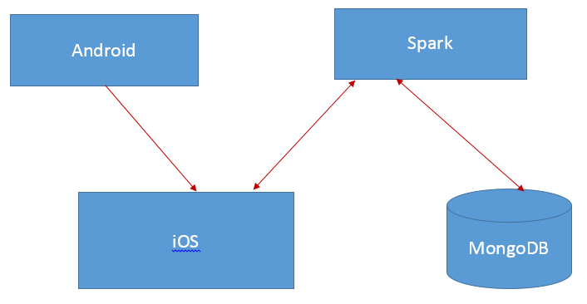

**4. System Features**

Peer-to-peer communication:

Using socket communication we send commands from Andriod to iOS app.

Speech to Text:

We used google speech to text API in Android app to convert speech commands to text and send them to iOS app.

Robo Movement based on situation:

Based on speech commands robo movement is handled. Robo will move all around based on situation and inputs.

Gesture Recognition:

Based on hand gestures, we are able to control the Robo from android app.

Accelerometer & Gyroscope:

We have used iPhone’s accelerometer & gyroscope data and filtered it to handle the robo movement.

Natural Language Processing:

Using open NLP API’s we have implemented the natural language processing feature to handle basic question and answering.

Color Detection:

We have implemented color detection feature to control robo movement i.e. to stop etc.

Sing-a-song:

Based on sing command we are able to make the robo sing a song, we are using this feature to change the mode of a person.

Weather updates using API:

We have used ‘Open Weather’ API to forecast weather conditions based on location. Successfully implemented location feature also.

SMS using twilio API:

We have used ‘twilio’ API to send SMS to concern person based on situation.

Image Classification:

We have tried to implement image classification feature to detect food items. But we are not successful in completely implementing.

Calorie Calculator for Food items:

We are using spark programming to calculate calories of food items which a person in one day. We have coded this self API using food-calorie dataset which have created for more than 500 food items.

Diet Recommendations:

We are using above calorie calculator feature to recommend food items for a person based on age and gender.

Sentiment Analysis:

We are using sentiment analysis feature on Spark side to know the mindset of a person. We are implementing this using speech of a person.

MongoDB:

We are retrieving calories need for a person based on age from MongoDB.

**5. Implementation Details:**

Following are implementation details of our project.

1. iOS is acting as server and Android & Spark systems acts as clients. We are also using MongoDB to store the age based calorie data.
2. Peer-to-peer communication using socket connection we are sending commands from Android app to iOS app. And iOS app sends commands to Spark and the process is performed there and the action to be taken is given to iOS app. In the same way the response is sent back from iOS to Android.
3. We are using Natural Language Processing (NLP) feature to perform basic and advanced question & answering features.

**6: Results/ Evaluations:**

**MongoDB Database Screenshot**

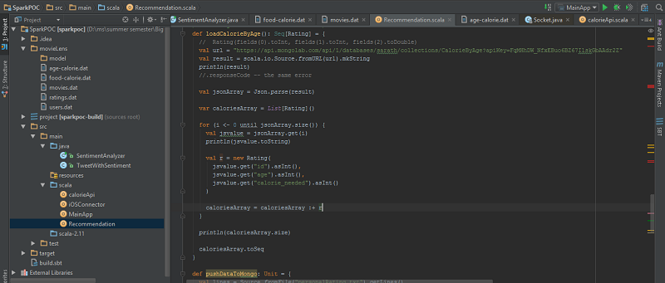

**Screenshot for Food-Calorie Calculator using Spark Programming**

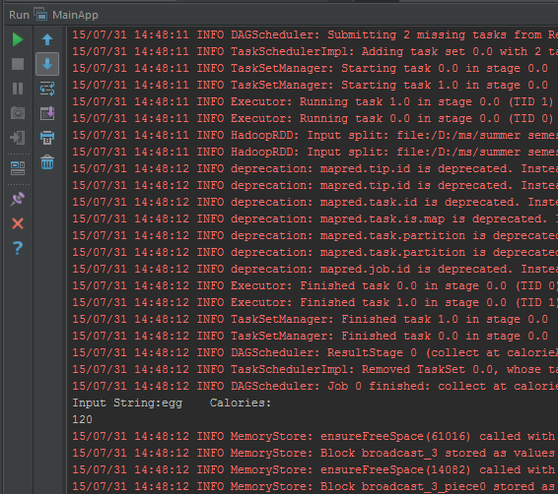

Screenshot for Food Recommendation for a person with age 25 & gender male

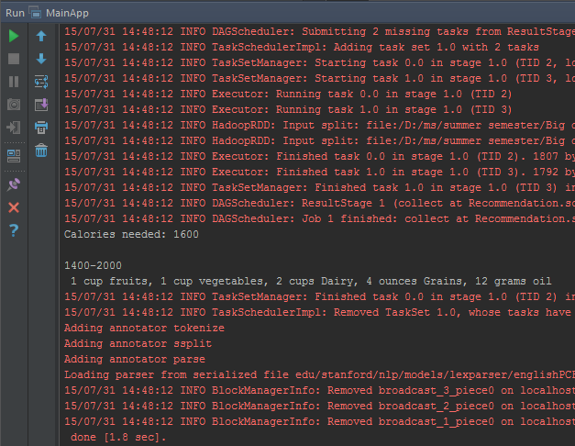

**Screenshot for Sentiment Analysis (Positive-negative check) based on the input from Speech**

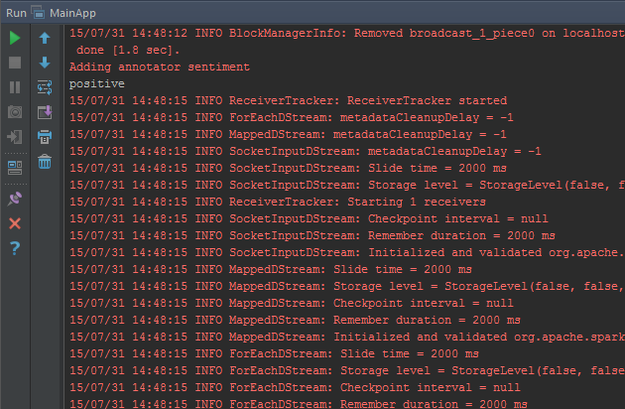

**Dataset Screenshot**

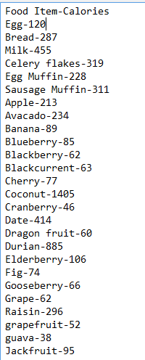

**7. Conclusion**

We were able to implement good part of project which we initially thought of. This was good learning curve for our team members working on different technologies and integrating the work which we have done on different systems.

**8. Future Work**

We didn’t succeed in implementing one feature which we thought of initially one is fetching the blood pressure of a person using S Health app. We will be working on this to implement this successful to automate health tracking to lot extend.

**9. References**

1. Twilio SMS API
2. Open Weather API
3. OpenCV Framework
4. MongoDBlab.com
5. Full Work Flow tutorial
6. Spark.apache.org/docs